FORM A - REQUESTER INFORMATION
To be completed by Requester
- See RTD-CAP-PLY-001
- Disruption to RTD services is highly discouraged. Staff will work with external parties to 1) eliminate, or, if necessary, 2) reduce the impact of the service disruption.
Project Name

Contact
Company/Agency
Email
Phone
Service Routes affected
Duration of Service change
Location of Project with nearest major streets
Description of Overall Project
Description of Scope of work that affects RTD
Form Completed by:
Date

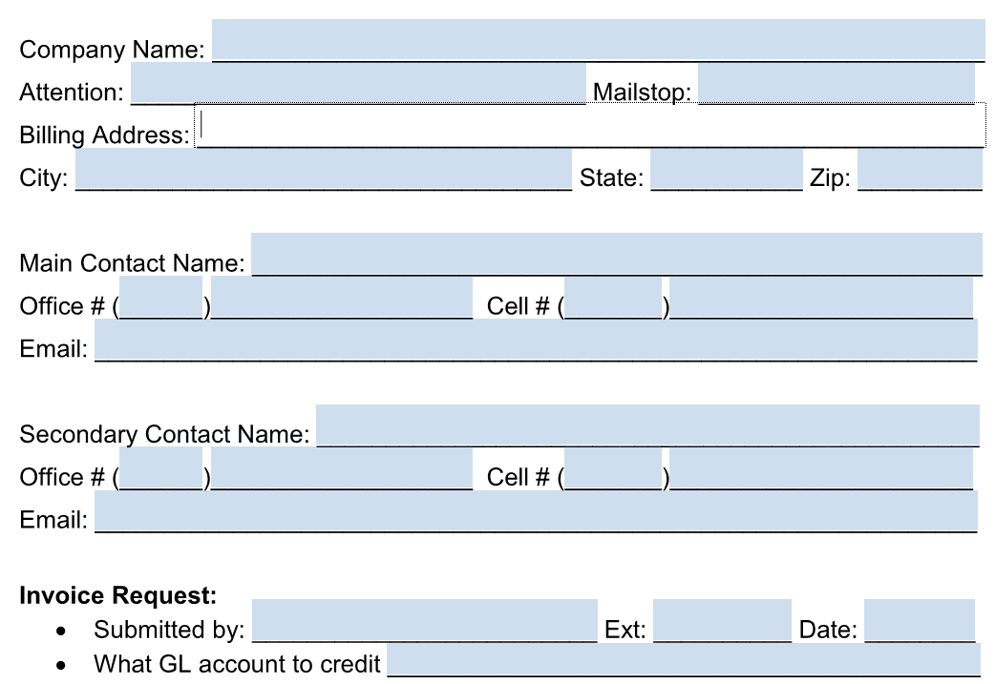

FORM C – LIGHT RAIL DISRUPTION REQUEST
To be completed by RTD Rail Maintenance of Way Divisions
This form only applies to non-RTD projects, and event closures.
- See RTD-CAP-PLY-001
- Disruption to RTD services is highly discouraged. Staff will work with external parties to 1) eliminate, or, if necessary, 2) reduce the impact of the service disruption.
PLANNING ESTIMATE:
Item | Unit Rate | Rate | Number of Units |  | Cost
 |  |  | Planned | Actual | Planned | Actual
Light Rail Maintenance of Way Flagger | Per person, per hour | $40
Shutdown / power down | Per occurrence | $500
Signal traction power maintainers | Per person, per hour | $50
TOTAL

Prepared By | Name | Date

I agree to pay the above charges. I understand that RTD will bill me for this work.

Requestor | Name | Date

On behalf of

