Transit Service Policies & Standards

*Approved*

*July 19, 2016*

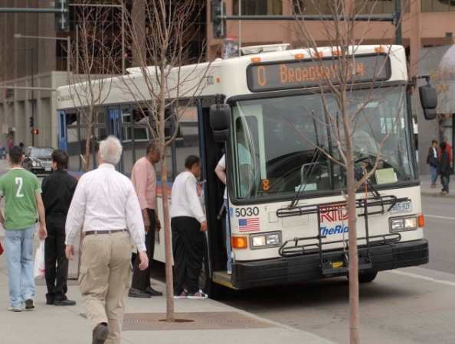

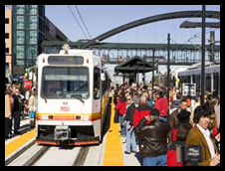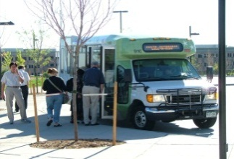

RTD Logo Red.emf

RTD Logo Red.emfRegional Transportation District

RTD Logo Red.emf

**Regional Transportation District**

**1600 Blake Street**

**Denver, CO 80202**

RTD Logo Red.emf

**Regional Transportation District**

**1600 Blake Street**

**Denver, CO 80202**

RTD Logo Red.emf

**Regional Transportation District**

**1600 Blake Street**

**Denver, CO 80202**

Table of Contents

1. Introduction 1

1.1 Overview 1

1.2 Application of Service Standards 1

1.3 Updating of Service Standards 2

2. Performance Standards 2

2.1 Derivation and Use of Standards 2

2.2 Ridership and Economic Measures 3

2.2.1 Performance Objective 3

2.3 Fixed Route Service Design and Evaluation Standards 4

2.3.1 Minimum Service Frequency 4

2.3.2 Minimum Ridership Performance 5

2.3.2.1 Performance Standards 5

2.3.2.2 Specific Trips Ridership Standards 5

2.3.3 Maximum Load (Crowding) Standard 6

2.3.4 Demand Based Service Frequency 7

2.3.5 Vehicle Assignment Targets 7

2.3.6 Design and Evaluation of Portions of Routes 8

2.3.6.1 Midline Segments and Midline Deviations 8

2.3.6.2 Branches and End Segments 8

2.4 Demand Response Service Design and Evaluation Standards 9

2.4.1 Call-n-Ride 9

2.4.2 Access-A-Ride 9

2.4.3 Vanpooling 9

2.4.4 SeniorRide and Senior Shopper 10

2.5 Reliability 10

3. Geometric Design Standards 10

3.1 Directness of Route 10

3.2 Stop Spacing Standards 11

3.2.1 Minimum 11

3.2.2 Maximum 11

3.3 Roadway Design Goal 11

4. Shelters 11

5. Area Coverage Standards 11

5.1 Purpose and Application 11

5.2 Coverage Levels Outside the Denver CBD 12

5.2.1 Minimum Service Levels 12

5.2.2 Access-A-Ride - ADA Required Service Area Coverage 12

6. Transit Access 13

7. Service Guidelines for Special Events and Special Services 13

7.1 Derivation of Standards 13

7.2 Standards for Events 14

8. Shuttles & Circulators 14

8.1 Characteristics 14

8.2 Guidelines for Success 14

9. System-Wide Cost Recovery Standard 15

10. Title VI & Environmental Justice Compliance 15

11. Standard for Service for Transit Dependent Persons and 16

To Social Service Destinations 16

11.1 Purpose of the Standard 16

11.2 Determination of Transit Dependency 16

11.3 Application of Transit Dependency Standard 17

12. Service Change Process 17

13. Cost Sharing Policy 18

13.1 Background 18

13.2 Guidance 18

13.2.1 Financial Feasibility 18

13.2.2 Vehicle Availability 19

13.2.3 Local and Community Support 19

13.2.4 Performance 20

**List of Figures**

Figure 1 Effectiveness - Productivity Chart 4

**List of Tables**

Table 1 Minimum Service Frequency 5

Table 2 Specific Trips Ridership Standards 6

Table 3 Demand Based Service Frequency 7

# Introduction

## Overview

RTD continually receives requests for changes to existing service and for new service in growing areas of the District. Additionally, RTD may be operating some services that are not attracting enough riders to justify their cost. In order to be consistent in the evaluation of service proposals, and to ensure that the service being provided represents the most cost-effective use of the District's resources, a set of service standards is maintained by RTD.

The specific standards, targets or minimum/maximum values for the standards, and a procedure for applying these standards, are presented in this document. Since service standards are intended to optimize usage of the District's resources, they are updated periodically to reflect changes in the District goals and resources. The procedure for updating the standards is described in Section 1.3.

## Application of Service Standards

There are two primary applications for the ongoing use of the service standards. These are the use of standards to evaluate existing services, and use of standards to evaluate proposals for new service.

The application of standards to existing routes is a flexible process. The purpose of the standards is to help identify routes which are most in need of service changes, such as restructuring to eliminate lower productivity segments or branches, adjusting service frequency to better reflect the demand for service, or providing additional promotion of less patronized routes where appropriate. Routes, which do not meet standards, are not automatically designated for elimination. Elimination of routes is only intended as a last resort, when it has been determined that no cost-effective actions are available to improve the productivity of the route.

The standards for evaluation of existing routes are not intended to preclude changes to routes that meet these minimum standards. In many cases, it may be possible to improve the productivity of routes that meet the minimum standards by making changes to headways or trip times. Since the overall mission of RTD is *“To meet our constituents’ present and future public transit needs by offering safe, clean, reliable, courteous, accessible and cost-effective service throughout the District,”*these standards should not be used to prevent changes to improve the efficiency of existing routes, as long as the changes meet the route design standards.

The availability of financial resources, represented by the annual budget, is the bottom line for these standards. Service expansion may occur when additional funds are available and contraction may occur otherwise. In any case, selection of which services to provide or curtail is based on these performance standards and no service is considered guaranteed or beyond review. The RTD Board of Directors, with input from RTD staff and the public, is responsible for making decisions on service recommendations.

The evaluation of new service proposals will take place as proposals are received or needs identified. The most recent values of the standards for existing routes will be used to evaluate the proposed new services. Decisions regarding implementation of new routes will be made through the service planning process. New routes and services will be expected to meet all applicable design standards described in Sections 2, 3 and 54, but will not be expected to meet the productivity standards described in Section 2.3.2.1 until they have been in operation for at least six months. Demonstration, experimental, and cost sharing services are also handled in this manner.

## Updating of Service Standards

The service standards are intended to support the goals and objectives of the District. Since these objectives and the resources available to attain them can be expected to change over time, the standards will be revised periodically to reflect those changes.

The service standards will be reviewed on a bi-annual basis. At that time, experience with the service standards over the previous time period, as well as changes in the District's goals and objectives, will be used to determine whether any standards should be added or revised.

The numerical values of productivity standards will be updated each year, using ridership, revenue and cost figures for the most recent twelve-month period for which data are available. The rankings are based only on those routes that existed for the entire year. Routes which were eliminated during the year will not be included because they cannot be identified as candidates for revisions. Routes that were introduced during the year will not be included in determining the new standards since they are not required to meet the productivity standards until they have been in operation for at least six months. However, these routes will be evaluated separately, using the service standards contained in this document.

The updating procedure will compare the values of the productivity standards with those in effect for the previous year. Operating cost data for the previous year will be revised to account for system-wide increases or decreases in operating cost.

# Performance Standards

## Derivation and Use of Standards

The productivity standards are used to identify routes and services for appropriate marketing and possible revision or elimination. Separate standards are identified for each class of service. Routes are evaluated on ridership (either boardings per in-service hour or per trip, depending on the class of service) and on the economic measure of subsidy per passenger. These standards are based on the performance of the least productive 10 percent of the routes in each service class for either the ridership or economic measure, or on the least productive 25 percent of routes in both measures. The basis for the standards will be reviewed in conjunction with the cost recovery standards in Section 9, and may be revised if necessary.

New services should meet the applicable standards for their class of service after six months of operation. All new services will be reviewed after six months of operation and routes that have not shown adequate progress toward meeting the standards will be targeted for cost-effective actions to increase productivity or for elimination.

To meet the RTD mission to provide *cost-effective service throughout the District,* RTD has developed different types or classes of service that serve specific markets and, therefore, have different performance expectations. Due to their different service characteristics Express, Regional and SkyRide were treated as separate classes. However, due to the deployment of rail, BRT and resulting service restructuring, these classes are reconfigured. The routes in these three are reassigned into a new, consolidated Regional class or the Local CBD class. Regional class includes routes providing high-speed service on limited access highways from suburban and outlying communities to downtown Denver, Denver International Airport and other metro, major employment centers, and provided at distances of approximately 6 miles or more. Local services have three sub-classifications: CBD—any route serving downtown Denver; Urban—35% or more of route length within a ¼ mile buffer has population+employment density of 12 per acre or greater; and Suburban—34% or less. Call-n-Ride and Access-a-Ride are separate classes. Enhanced bus and BRT routes may warrant future consideration regarding their operation with: dedicated right-of-way; partially dedicated ROW; limited or express mode; priority over other traffic; and various speeds appropriate to context. [Please see attachment A Service Classes for details on how these revisions affect current routes.]

The standards for evaluating portions of routes are intended for use in identifying needed service improvements, for making modifications to specific portions of existing routes, or for identifying low productivity segments of routes.

These standards could be used in situations such as isolating low productivity portions of otherwise productive routes or measuring options for bringing unproductive routes into compliance with the overall service standards. These standards may also be used to evaluate proposals for new route extensions or deviations on existing routes.

## Ridership and Economic Measures

The RTD’s approach is to develop a family of transit services suited to a variety of travel markets. All services are designed to match the level of service with demand, thus improving performance and sustainability. This results in multiple domains of acceptable performance for the various classes of service. Standards are best set by first determining measures of performance and objectives. The core objective is to maximize overall ridership, to the extent allowed by the available resources.

### Performance Objective

Service allocation is driven by the RTD adopted mission statement: “To meet our constituents’ present and future public transit needs by offering safe, clean, *reliable,* courteous, accessible *cost-effective service throughout the District*.”

Performance Measures

* Passengers/hour (productivity)
* Passengers/trip (Regional class productivity)
* 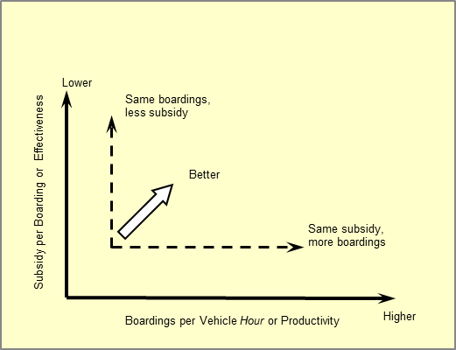Subsidy/passenger (cost effectiveness)

The subsidy per passenger measure combines fare revenue and total cost impacts to produce a measure that comprehensively reflects the District’s allocation of resources. The effectiveness-productivity chart, Figure 1 - Effectiveness - Productivity Chart, presents economic effectiveness on the vertical axis, and productivity, or boardings per hour, on the horizontal axis. The chart offers a convenient comparative analysis of all classes of services, illustrating both absolute and relative performance. When standards and guidelines are applied, judgments can be made.

Figure 1 Effectiveness - Productivity Chart

## Fixed Route Service Design and Evaluation Standards

### Minimum Service Frequency

New routes shall provide the minimum frequencies specified below. Existing services that cannot meet these minimum standards while adhering to the minimum passengers per hour or trip standards defined in Section 2.3.2 shall be identified as candidates for service changes or appropriate marketing promotion within available resources. These service changes may include providing service with longer headways if no other viable alternative exists. Elimination of the route may be considered if service changes and/or promotional efforts do not improve productivity.

These are “policy” service levels and represent a compromise between economic efficiency and the functionality of the system. To be sustained at these levels, a route must meet the minimum ridership performance standards discussed in Section 2.3.2.1 and annual calculated standards. Routes providing frequencies higher than the policy minimum must be justified by ridership demand as outlined in Section 2.3.4.

The following table indicates the minimum frequency standard for types of service and time of day by corridor (multiple routes sharing a segment).

|  |  |  |
| --- | --- | --- |
| Service Type | Span of Service | Minimum Frequency |
| Local – Peak period | Mon–Fri 6:00am to 9:00am and 3:00pm to 6:00pm | 30 minutes |
| Local – Off peak below 25% boardings per hour | Weekday midday (9:00am – 3:00pm) | 60 minutes |
| Local – Off peak above 25% boardings per hour | Weekday midday | 30 minutes |
| Local | Evenings and weekends | 60 minutes |
| Regional to CBD | 3 peak trips, Mon – Fri. Trips should target 7:00, 7:30, 8:00 AM shift work start times and 4:00, 4:30, 5:00 PM shift end times. | |
| Rail & Enhanced Bus (BRT) | Weekday 6:00am – 6:00pm | 15 minutes |
| Rail & Enhanced Bus (BRT) | Weekday evenings 6:00pm – 11:00pm and Saturday | 30 minutes |
| Rail & Enhanced Bus (BRT) | Night after 11:00pm | 60 minutes |
| Rail & Enhanced Bus (BRT) | Sunday and holidays | 60 minutes |
| SkyRide | 3:00am to 1:00am daily | 60 minutes |

Table 1 Minimum Service Frequency

### Minimum Ridership Performance

This standard applies to routes operating at the minimum service frequency target. For **Local** and **Limited** routes, the standard is passengers per hour based upon the bottom 10% and 25% of routes in the respective class. For **Regional,** and **SkyRide** routes, the standard is passengers per trip.

These standards are derived from system averages by class of service. All routes must meet their applicable minimum standards. Those that do not meet these standards will need to be modified or marketed in some way in order to bring them up to the minimum standards. Those that are not brought up to the minimum standards are subject to cancellation. Routes that meet their applicable minimum ridership standards justify a service level at the minimum service frequencies outlined in Section 2.3.1. Higher frequencies must be justified by ridership as outlined in Section 2.3.4.

#### Performance Standards

These measures and the effectiveness-productivity for all routes and services and the class 10% and 25% standards are calculated annually and are provided separately at <http://www.rtd-denver.com/ServiceDevelopment.shtml>, under Service Development Documents—Performance Reports.

#### Specific Trips Ridership Standards

The standard for evaluating specific trips on a route varies by time of day as shown in the following table. For reference see the last column of Attachment C Regional Bus Service Performance. Trips must have boardings of at least the specified percentage of the minimum boardings standard for the time period of the trip, as defined in Table 2

* On Regional routes with more than three trips and which provide only peak period service, the first and last trips must have minimum boardings of one-half the average for the class if the overall route meets the minimum boarding standard. For other routes Table 2 applies.

|  |  |
| --- | --- |
| Time of Day for Service Class | Percentage of Average Ridership |
| 5:00 am - 6:00 am | 75% |
| 6:00 am ‑ 8:00 pm | 100% |
| 8:00 pm ‑ 11:00 pm | 75% |
| 11:00 pm ‑ 5:00 am | 50% |
| First or Last Trip | 50% |

Table 2 Specific Trips Ridership Standards

* On rail, the first trip of the operating day in each direction, operated as the “Sweep Train” and pull-outs, is exempted from the minimum ridership standards.

### Maximum Load (Crowding) Standard

From the Transit Capacity and Quality of Service Manual: “From the passenger perspective, the passenger load on a transit vehicle affects the comfort of the on-board vehicle portion of a transit trip-both in terms of being able to find a seat and in overall crowding levels within the vehicle. From a transit operator's perspective, a poor quality of service may indicate the need to increase service frequency or vehicle size to reduce crowding and increase passenger comfort.”

RTD defines crowding as a seated load plus the standing passenger space, as calculated for each vehicle by subtracting the area occupied by seats and other objects from the gross interior floor area. The amount of crowding on a route is defined as the percent of total trips during a defined time period that exceed a comfort passenger level of 4.3—5.3 square feet per standee, generally having these characteristics (See page 5-24 of the Transit Capacity and Quality of Service Manual, 3rd Edition, <http://onlinepubs.trb.org/onlinepubs/tcrp/tcrp_rpt_165ch-05.pdf>):

* Standing load without body contact
* Standees have similar amount of personal space as seated passengers
* Reasonably easy circulation within vehicle

The maximum number of standees can be computed for each vehicle by determining its standing passenger square footage and dividing by 4.3—5.3. For any service class during any defined period (e.g., AM early, AM peak, midday), when 10% or more of the directional trips exceed the computed maximum standees at the maximum load point, further investigation of potential remedies, such as changing the bus assignment or frequency of service, is warranted. For special events heavier loads are expected and acceptable, but when 10% or more of trips during the take-away have 4 or less square feet per standing passenger, further investigation of potential remedies is warranted. See Attachment D Crowding Report Examples for reference. The Percent of Total Trips chart (lower right) with level-of-service D or E would indicate crowding.

### Demand Based Service Frequency

Service frequency in the RTD network is based on clock-pattern schedules. This pattern provides consistent and easy to understand schedules for our customers, and makes possible the provision of timed transfer connection hubs, whereby multiple routes are scheduled to meet at one location to facilitate connections. In general, routes are scheduled to operate in even increments of 30 minutes, or every 60, 30, 15, 10, 7.5, or 5 minutes. However, other frequencies may be provided depending upon passenger demand, or operational and scheduling needs.

For routes meeting the above frequency, ridership, and load standards, frequency better than every 30 minutes may be provided when and where justified by ridership. This standard applies equally to all service categories. In order to be sustainable, higher frequency service must meet the following criteria:

* Incremental frequency necessary to maintain the appropriate load standard during any 30 minute time period.
* Appropriate vehicle assignment as outlined in Section 2.3.5
* When a service exceeds the maximum load standard, higher frequency may be justified during that time period and/or route segment.
* If a service with better than the minimum frequency has passenger loads that can be accommodated with a lower frequency without violating the load standard, then frequency may be reduced.
* As a general guideline, a typical productivity by service frequency, for a whole route or a segment or time period is provided in Table 3 - Demand Based Service Frequency

|  |  |  |
| --- | --- | --- |
|  | Boardings Per Hour | |
| Frequency | Route | Segment-Period |
| 60 - 30 minutes | Minimum for Class | - |
| 15 minutes | 25 - 39 | 35+ |
| 10 minutes | 40+ | 45+ |

Table 3 Demand Based Service Frequency

### Vehicle Assignment Targets

Equipment shall be assigned to specific routes and trips according to the following guidelines. These guidelines may be modified if operational and scheduling needs require.

* Small 27’-30’ Bus: Appropriate for lower volume **Local** routes where ridership does not require a standard bus, or for routes where specific operating concerns preclude use of standard buses and for **Call-n-Ride**.
* Standard 40’ Transit Bus: The standard equipment for **Local** and **Regional** services.
* Articulated 60’ Bus: Appropriate for higher volume Limited and Regional services.
* Intercity Coach: Appropriate for Regional and SkyRide services.

### Design and Evaluation of Portions of Routes

The standards for evaluating portions of routes cover two areas in which minor modifications may be made to routes without changing the overall structure of the route:

* midline segments or midline deviations
* branches or end segments

The governing standards for overall route productivity were presented earlier. Since trips provided during marginally productive hours of the day or trips over marginal segments often increase the attractiveness of the overall service, an otherwise productive route may be able to support some less productive trips or portions of the route. However, if a route cannot meet the overall service standards for its class of service, there may not be productive segments to enhance the unproductive segments. Therefore, specific segments, branches, or trips which meet the standards for portions of routes may still be modified in order to raise the productivity of the entire route, if the overall route does not meet the service standards for its class of service.

#### Midline Segments and Midline Deviations

* A midline segment or deviation of a Local or Limited route should generate enough boardings per hour of service provided to meet the standard for its class of service (CBD, Urban and Suburban). Boardings in both directions will be counted.
* If a route is changed, the change shall not cause a reduction in the overall boardings per hour for the route.
* If a route is changed, the change shall not cause the route to violate any route design standards as defined in Section 2.3, or the overall productivity standards as defined in Section 2.

#### Branches and End Segments

* A branch or end segment of a **Local** or **Limited** route should generate enough boardings to meet the ridership standard for its class of service (CBD, Urban and Suburban).
* Boardings generated along the branch are defined as all passengers boarding the bus along the branch or end portion of the route, and all outbound passengers alighting along this section.
* Local collector portions of **Regional** routes which meet the following maximum travel time standard shall meet the ridership productivity standard for the entire route. This maximum travel time is equal to 15 minutes or 50 percent of line haul travel time, whichever is less.
* For shorter segments, the minimum ridership standard is reduced by the ratio of actual travel time to the maximum allowable travel time. Thus, if the actual travel time along the collector is half of the maximum allowed, it must average half the number of boardings per trip specified in the minimum ridership productivity standard.
* A new extension to a route that does not meet the minimum ridership productivity standard must attract sufficient ridership for the entire route to meet the minimum ridership standard for its service class.
* A route extension will not be initiated if it violates any of the route design standards found in Section 2.3, or causes the route as a whole to fall below the minimum riders per unit of service or standards found earlier in Section 2.3.2.

## Demand Response Service Design and Evaluation Standards

RTD continues to develop a family of transit services suited to a variety of travel markets. The goal of this approach is to match the type and level of service to the demand in a given service area, thus improving performance and sustainability. As such, a variety of non-fixed route services are provided by the RTD including the following.

### Call-n-Ride

Rather than operating on a fixed route and schedule, demand responsive Call-n-Ride service is characterized as a shared ride within a defined geographic service area and the need for the passenger to arrange for pick-up in advance or be at a designated checkpoint at prescheduled times. A Call-n-Ride service area averages about 7 square miles or between about 2 to 30 square miles depending on its number of vehicles and service configuration—predominantly station feeder or community-based service. Call-n-Ride often provides first/last mile access to the broader RTD network of services through timed connections at transfer centers and Park-n-Rides. Population plus employment is 3 to 12 persons per acre. Call-n-Ride service is evaluated based on passenger boardings per revenue hour and subsidy per passenger boarding.

### Access-A-Ride

Access-a-Ride provides ADA complementary paratransit in the District to individuals who cannot readily access the bus and rail system. As per US DOT requirements the passenger’s trip origin and destination must be within ¾ mile of RTD’s non-commuter bus route system, during the same days and hours of their operation and within the District boundaries, and curb-to-curb service must be provided. However, RTD provides door-to-door service as a reasonable accommodation. Trips must be booked at least one day and up to 3 days in advance; however, RTD also offers subscriptions.

All applicants must qualify for certification under the guidelines established by the Americans with Disabilities Act of 1990, complete a functional evaluation in person, provide a physician’s statements to verify disability and must meet one of the following criteria:

* Be unable to get to and from a bus stop or on and off a lift-equipped bus by yourself
* Have a cognitive disability that prohibits your understanding of how to complete bus trips

### Vanpooling

Vanpooling is a public transportation option in which commuters, whose residences are geographically clustered, ride together to and from their work sites in a van that is driven by one of the vanpool participants. Typically vanpools make one roundtrip per day and carry from 5 to 14 riders. Vanpooling offers greater opportunities for increased capacity compared to carpooling and offers a cost-effective alternative to conventional transit in areas of low employment density and longer commute distances. RTD contracts for this service with DRCOG to subsidize the portion of the commute trip within the District. Vanpool service is evaluated based on subsidy per passenger boarding.

### SeniorRide and Senior Shopper

SeniorRide Special Events transports groups to a variety of cultural, educational and entertainment events. The Schedule of events is published 3 times a year to the public. Service is available on a first come first served basis. A minimum of 10 passengers per trip is required. Scheduled events that do not generate reservations of at least 2 groups of 10 may be reconsidered as to whether or not to schedule such event(s) during the next 12 months.

SeniorShopper buses have established routes that provide trips to major grocery stores. Service is available Monday through Friday. A minimum of 10 passengers per trip is required.

## Reliability

On-time for fixed-route service is defined as not more than 1 minute early to not more than 5 minutes late. RTD sets annual objectives for on-time performance by class of service and which are reported in the Quarterly Performance Report. [Improved methods for monitoring, identifying the causes and remedying unreliable service are currently in development.]

# Geometric Design Standards

## Directness of Route

Routes shall be designed to be as direct as possible and to provide maximum accessibility to transit.

* Deviations from a direct path from end‑to‑end of the route shall account for no more than one‑quarter of the end‑to‑end travel time of the route.
* For a specific deviation, the total additional travel time for all through passengers should not exceed three minutes for each rider boarding or alighting along the deviation.

In mathematical terms, this means that the quantity

Pt * VTT < 3 minutes

Pd

where: Pt = through passengers

VTT = additional vehicle one-way travel time Pd = passengers served by deviation

## Stop Spacing Standards

Bus routes shall adhere to the following stop spacing standards. Placement also considers: the balance between pedestrian access and route travel time; ADA requirements; adjacent land uses; streetscape conditions and property ownership.

### Minimum

* **Local** and **Regional** collection, residential areas ‑ 600'

(8 stops/mile) Commercial areas ‑ 500' (10 stops/mile)

* **Limited** service, limited‑stop zone ‑ 2500' (2 stops/mile)

### Maximum

* **Local** service, residential and commercial areas – 1,250’ (4 stops/mile)
* **Limited** service, residential and commercial areas – 1,250’ (4 stops/mile)
* **Limited** service, limited stop zone – 8,000’ (1 stop/1.5 miles)

## Roadway Design Goal

New bus routes should *not* be operated along streets that do not meet minimum standards, such as for bus turning radius, pavement strength/loading, lane width, roadway grade, shoulder width on rural roads (for pedestrian waiting and safety) and overhead clearance. Refer to the RTD Bus Infrastructure Design Guidelines and CriteriaSection 1 – Transit Access for specific details.

# Shelters

The minimum warrant for the placement of a shelter is 40 boardings per day at the stop. Stops with the highest average of daily boardings will take top priority for shelter placement. [Revised standards are currently in development and will reference the RTD Bus Infrastructure Design Guidelines and Criteria.]

# Area Coverage Standards

## Purpose and Application

The purpose of these standards is to define a reasonable level of service to all areas of the District and to help RTD maintain this service level. Since the RTD service area includes many different types of development, and population densities and land use vary widely across the District, it would not be reasonable to expect all areas to support the same level of service. Moreover, different types of service may best meet the needs of different areas, and RTD's resources can be used in a more productive fashion if service can be tailored to the needs of particular areas. Area coverage standards provide guidelines for tailoring service to the needs of communities and help ensure that all areas receive a level of service that is commensurate with their needs.

Levels of service for specific areas also depend on the productivity of existing services. If existing or proposed services cannot meet the productivity standards outlined in Section 2, RTD may choose not to provide the minimum level of service. Financial constraints may also limit RTD's ability to meet the area coverage (or any other) standards.

## Coverage Levels Outside the Denver CBD

The area coverage standards for areas outside the Denver Central Business District (CBD) are based on a combined density measure. This measure adds population and employment to determine potential demand for transportation to and from a particular area. [Attachment B shows the density classifications overlaid with RTD services for the entire District.]

The area coverage standards presented below deal with route spacing. Actual route spacing and service frequency will depend on demand and productivity of existing service in the area.

For use in this document, arterial roadways are defined as follows:

* Traffic flow controlled by traffic signals as opposed to stop signs
* Carry longer distance traffic flow
* Speed limit 30 mph or faster
* Road width two plus lanes in each direction

### Minimum Service Levels

Areas with 3‑12 residents and employees per acre

* Peak period Park-n-Ride service if either the travel time to the Denver CBD by Express bus or rail, or a bus/rail timed connection, exceeds 20 minutes.
* Call-n-Ride service.

Areas with 12 or more residents and employees per acre:

* Local service on major arterials with pedestrian access within 1/4 mile.
* Peak period, Limited, Express, or Regional service from Park‑n‑Rides if either the travel time to the Denver CBD by bus, or a bus/rail timed connection, exceeds 20 minutes.

### Access-A-Ride - ADA Required Service Area Coverage

Within the District:

49 CFR 37.131 - Service criteria for complementary paratransit.

**“(1)** ***Bus.***

**(i)** The entity shall provide complementary paratransit service to origins and destinations within corridors with a width of three-fourths of a mile on each side of each fixed route. The corridor shall include an area with a three-fourths of a mile radius at the ends of each fixed route.

**(ii)** Within the core service area, the entity also shall provide service to small areas not inside any of the corridors but which are surrounded by corridors.

**(iii)** Outside the core service area, the entity may designate corridors with widths from three-fourths of a mile up to one and one half miles on each side of a fixed route, based on local circumstances.

**(iv)** For purposes of this paragraph, the core service area is that area in which corridors with a width of three-fourths of a mile on each side of each fixed route merge together such that, with few and small exceptions, all origins and destinations within the area would be served.

**“(2)** ***Rail.***

**(i)** For rail systems, the service area shall consist of a circle with a radius of 3/4 of a mile around each station.

**(ii)** At end stations and other stations in outlying areas, the entity may designate circles with radii of up to 11/2 miles as part of its service area, based on local circumstances.

**“(3)** ***Jurisdictional boundaries.***Notwithstanding any other provision of this paragraph, an entity is not required to provide paratransit service in an area outside the boundaries of the jurisdiction(s) in which it operates, if the entity does not have legal authority to operate in that area. The entity shall take all practicable steps to provide paratransit service to any part of its service area.”

“Requirements for complementary paratransit do not apply to **commuter bus** … fixed route bus service, characterized by service predominantly in one direction during peak periods, limited stops, use of multi-ride tickets, and routes of extended length, usually between the central business district and outlying suburbs.” [§37.121]

# Transit Access

RTD has guidelines for access to its facilities for pedestrians, bus riders, bicyclists, passenger loading, and parking. The RTD Bus Infrastructure Design Guidelines and Criteria, included here by reference, is intended to be used by RTD in conjunction with local jurisdictions in planning transit access (including projects under construction).

# Service Guidelines for Special Events and Special Services

## Derivation of Standards

The following guidelines for provision of bus and/or train service to special events are based on prior RTD Board actions and on the public convenience and necessity to:

* Protect neighborhoods from the impact of events which are so large as to overwhelm the surrounding supply of parking, and
* Serve customers by offering adequate service for events which are predictably large enough to overload the normally available transit service, and
* Protect taxpayers by only serving those events that have a predictable level of transit demand great enough to justify the operation of special routes.

## Standards for Events

RTD, within the limits of its budget, will operate special service:

* For events at Invesco Field at Mile High stadium with projected attendance of over 55,000, for which the crowd is expected to all be present at one time.
* For events at Coors Field with projected attendance of over 40,000, for which the crowd is expected to all be present at one time.
* At other venues where the ratio of projected attendance to available on-site parking is 6:1 and for which the crowd is expected to all be present at one time.

This service will not be provided when substantial numbers of the event patrons can be expected to arrive in privately operated or non-profit owned buses or regularly scheduled RTD service.

RTD will provide Express Shuttle service to Invesco Field and Coors Field from selected Park-n-Rides for events described in this section. The General Manager must specifically authorize Park-n-Ride service for other events.

# Shuttles & Circulators

## Characteristics

Shuttle and circulator routes are not defined as a separate class of service, but are typically proposed to serve specific, local, community-focused needs. Shuttle and circulator routes are generally defined by the following characteristics: short routes, usually less than 5 miles long; operate on local streets and arterials; connect major activity centers; and serve short passenger trip lengths within a single community. Fares must be set according to RTD Fare Policy.

## Guidelines for Success

Several factors are critical to shuttle and circulator success. As a guideline to make informed decisions, the following characteristics must be present and considered.

* A sustained average population density of at least 10 people per acre along the length of the route is a minimum requirement; a critical mass of potential riders is needed to succeed.
* Connects community residences with major activity centers such as colleges, high schools, middle schools, shopping districts (but not auto-centric malls), medical centers, and downtowns that appeal to all market segments (youth, families, seniors) and can serve a variety of trip purposes.
* Transit friendly environment: pedestrian friendly, walkable streets are a minimum; mixed land uses; areas of clustered shopping or employment; public spaces; and bicycle parking/paths.
* To attract spontaneous walk up use, the headway needs to be15 minutes or less for a service span for the intended markets, typically 6:00 – 18:00 or longer.
* Offers bi-directional service.
* Does not substantially duplicate a service of comparable utility.

# System-Wide Cost Recovery Standard

The state required system-wide minimum cost recovery ratio is 30 percent. This ratio is calculated by the following formula:

[Farebox Revenues + Advertising Revenues + Lease Revenues + FTA Operating Assistance + Other Non-Sales Tax Revenues ] **/** [Category Costs applied according to RTD Cost Model Memo, June 15, 2010, as updated (See summary below)]

**Cost Model Summary**

With the exception of Private Carrier costs, all costs are allocated to routes by one of three methods: hours, miles or vehicles. The RTD Bus Cost Model has five cost categories: Variable/Direct, Variable/Indirect, Private Carrier, Retained Costs and Depreciation. Private Carrier costs are allocated to routes by the number of hours the contractor operates the route, multiplied by the average hourly rate billed for that particular contract, plus the average hourly cost for fuel.

The annual budget and six-year Strategic Budget Plan are evaluated using this cost recovery standard. If the standard is not met, several courses of action may be taken. The RTD Board has adopted a policy of evaluating the fare structure as part of the annual budget process; fares may be changed at that time to provide additional revenue. RTD may also choose to market its services more aggressively to attract more customers and their fares, or RTD may look for revenue from other sources. The productivity standards in Sections 2 and 3 may be used to reduce the costs of providing service while disrupting service to as few passengers as possible.

# Title VI & Environmental Justice Compliance

RTD follows FTA Circular 4072.1B “Title VI Requirements and Guidelines for Federal Transit Administration Recipients,” Chapter 4.4.

Title VI Protected Classes are race, color and national origin.

Environmental Justice Protected Classes are as follows:

1. Minority Populations:

* American Indian and Alaska Native, which refers to people having origins in any of the original peoples of North and South America (including Central America), and who maintain tribal affiliation or community attachment.
* Asian, which refers to people having origins in any of the original peoples of the Far East, Southeast Asia, or the Indian subcontinent, including, for example, Cambodia, China, India, Japan, Korea, Malaysia, Pakistan, the Philippine Islands, Thailand, and Vietnam.
* Black or African American, which refers to people having origins in any of the Black racial groups of Africa.
* Hispanic or Latino, which includes persons of Cuban, Mexican, Puerto Rican, South or Central American, or other Spanish culture or origin, regardless of race.
* Native Hawaiian or Other Pacific Islander, which refers to people having origins in any of the original peoples of Hawaii, Guam, Samoa, or other Pacific Islands.

1. Low-Income Populations - 150% of Federal Poverty Guidelines.

# Standard for Service for Transit Dependent Persons and

# To Social Service Destinations

For purposes of these service standards, transit dependent riders are defined as riders who either live in a household which does not own a car or who have a physical or mental disability that prevents the transit patron from driving a car. Social Service destinations are those destinations that are provided as a public service that may not have consistently sufficient ridership to otherwise warrant the establishment or continuation of a route or route segment. Examples of social service destinations would include county court facilities, hospitals, schools, or public institutions which have been situated or constructed in isolated locations prior to the establishment of RTD or following review and comment by RTD of the proposed development plans of such institution or agency, by the appropriate jurisdiction.

## Purpose of the Standard

This standard is intended to provide for consideration of transit dependency in service decisions. This standard does not guarantee a minimum level of service to all transit-dependent riders. However, it will ensure that transit-dependent riders and/or the need to have access to social service destinations are identified and considered when decisions are made to reduce service levels in an area.

## Determination of Transit Dependency

Whenever RTD plans changes to an existing route where there is no alternative service available to meet the area coverage standards in Section 5 such as a change in routing or span of service, transit-dependent riders will be identified through on‑board surveys. This survey will ask questions about riders' travel habits and demographics, and it will attempt to identify transit-dependent riders and their destinations.

## Application of Transit Dependency Standard

The applicable minimum productivity standards for a route will be reduced by one-half the percentage of ridership that is defined as transit dependent. Thus, if 60 percent of the riders on a route are transit dependent, the route must achieve 70 percent [100 percent minus (60 percent divided by 2)] of the applicable productivity standards (ridership and economic) in order not to be considered a poor performer.

Applicable ridership standards for fixed route services may be found in Section 2.3, and for non-fixed route services, in Section 2.4.

If the on‑board survey reveals that the route does not serve the destinations desired by transit-dependent riders, RTD may restructure the route to improve service and increase ridership. This could include changing the routing or schedule to serve passenger needs. RTD wishes to provide transit dependent riders with service that fits their needs and to provide service to social service destinations when there is even a modicum of recognized demand.

Another consideration to be given in whether or not to eliminate a route with some transit dependent passengers is the impact on required Access-A-Ride services. The Americans with Disabilities Act (ADA) requires that eligible persons with disabilities be provided with paratransit service if they have trip origins and destinations within a defined service area three-fourths of a mile from a non-commuter fixed route. If accessible fixed route service is considered for removal from a portion of the defined paratransit service area, an estimate of the demand for substitute Access-A-Ride service for persons with disabilities who require lift-equipped buses must be completed and a cost-benefit analysis performed for the alternatives (leaving fixed route versus providing Access-A-Ride service).

# Service Change Process

The following is a description of the steps necessary in developing and implementing service changes, which are typically conducted each year in January, May and September—also called runboards—as required by Board policy and the Collective Bargaining Agreement.

Proposals are derived from a variety of inputs continuously throughout the year including: periodic customer, household and employer surveys; stakeholder meetings; service performance evaluation; and changing demographics and land uses. They are compiled for each runboard and evaluated based on a number of factors, including RTD annual budget, RTD Service Standards, effects on the transit network and on transit dependent markets (Title VI), cost-effective services throughout the District and responsiveness to changes in the communities within RTD. A Board paper is compiled and presented to the Board, stakeholders and public for consideration.

Staff then discusses the proposals with members of the Board, stakeholders and senior staff and coordinates with other staff including Marketing, Operations, Facilities and Finance. Modifications are made as warranted and then the proposals enter the pubic engagement process: formally scheduled public hearings; informal presentations upon request; repository for customer input—[service.changes@rtd-denver](mailto:service.changes@rtd-denver); responses to General Manager and Board Member requests. Upon completion of public engagement, all previous input is compiled and evaluated and revisions to the proposals are made as warranted. A final Board report is prepared with a summary and details of proposed changes and a summary of public hearings and other public input for approval of the Board.

The approved changes then go into a comprehensive production process which includes: schedule creation; bus and operator requirements and assignments; compliance with privatization policy; runcutting and compliance with the Collective Bargaining Agreement; marketing promotions and public relations; bus stop and on-street changes; printed and electronic public information, including maps and timetables; and validation and distribution of all data within the Transit Information Exchange System (TIES).

# Cost Sharing Policy

## Background

On June 21, 1994, the RTD Board of Directors passed a resolution, Transit Service Cost-Sharing Policy, to provide guidance to RTD staff in responding to the increasing number of requests for new service. This policy authorized the General Manager to pursue cost sharing as a method of providing transit service using RTD revenues and other funds voluntarily pledged by private employers, businesses or local governments; this has resulted in a number of RTD partnerships in demonstrating new services. The following incorporates this experience and provides guidance on the application and limitations of cost-sharing arrangements.

## Guidance

### Financial Feasibility

Financial feasibility depends not only on the availability of funds, but also on consideration of fares, cost/revenue allocation and equity.

* Net operating cost (subsidy) needs to be defined so that all partners are treated equitably. Net cost is the total operating cost less farebox revenue and other operating revenues and any grant revenues secured on behalf of the proposed service. The application of grant revenues prior to the net cost sharing allows all partners to participate in the benefits of grant funding.
* Cost-sharing projects need to adopt the RTD fare structure for similar services for reasons of equity. Furthermore, this places all projects on the same revenue basis for calculating net operating cost. Project sponsors may propose a fare that does not follow the RTD fare structure. For these projects the partner is required to fund the full difference in revenue between the comparable RTD fare and the project fare, based on actual ridership. The adoption of any non-conforming (economically or technically) fare is always subject to Board approval.
* Costs associated with vehicles are addressed project by project. Vehicles can be purchased outright by project sponsors with grant funds or provided from the RTD inventory. Should new vehicles be required, grants should fund their acquisition and the local share split equally by the cost-sharing partners. If no grant funds are used, RTD will limit its share to 10%, half of the usual local share when grant funds are used. If the RTD operates the service and agrees to provide the vehicles from its inventory, capital costs need not be included as part of the project cost unless special accommodations are required.
* Cost-sharing projects are new or expanded transit services and RTD’s share must be budgeted out of allocations for new services for the entire District. Thus any partner with expectations for RTD financial or operational participation must first obtain commitment from RTD before applying for project grants. In addition, each project will be subject to the appropriate RTD and DRCOG planning processes, especially as regards estimates of costs, ridership, revenue and other benefits.

### Vehicle Availability

RTD may have, with some minor modifications, vehicles readily available to provide the proposed service. In some cases projects require a specialty or significantly modified vehicle that must be acquired, subject to RTD approval for fleet maintenance compatibility. Financing these vehicles is addressed above. Sometimes the availability of operators has been more critical.

### Local and Community Support

Local and community entities (e.g., government, employers, businesses and associations) generally initiate cost-sharing transit projects concomitant with other plans and developments in the community. Thus the proposed transit project is designed to address a specific development or perceived need. To advance their project for implementation, an entity such as a city, will offer to share in the net costs of providing the service. RTD needs to be responsive to these requests, but keep them in the context of the needs of the entire District.

* Projects generally have substantial institutional support; however they are subject to the same public scrutiny, for example public hearings, as any other proposed service change. Implementation of any cost-sharing project will continue to be subject to RTD’s public review process.
* RTD generally provides 50% of the local share of the net operating and/or capital cost of a project. This cost-sharing ratio may be adjusted in consideration of the District budget and policies.
* Cost-sharing arrangements for each project are of limited duration for which agreed upon performance milestones must be reached (see below). The purpose of the test period is to assess the sustainability of the service and decide RTD’s and its partners continuing participation. The test period is typically set at one, two or three years, as appropriate to the project. Performance milestones must be set and evaluated and a recommendation regarding continuation made for each year of the project.

### Performance

Cost-sharing services will have clearly defined evaluative criteria agreed upon within the cost-sharing agreement and prior to implementation.

* At a minimum these criteria will include average daily ridership and RTD Service Standards within the appropriate class of service for passenger boardings per hour and subsidy per boarding. Additional criteria may also address issues related to project objectives, such as new riders. State mandated cost recovery may also be considered. Expectations of performance will be laid out in the form of milestones, such as a range or minimum attainment at the end of each year.
* During the first year performance will be assessed to determine if expectations have been met and if continuation of the service is warranted. Often an experimental service will need to be changed to improve performance. As warranted the same assessment will be made in each succeeding year during the test period. This assessment and recommendation regarding continuation will be reported to the RTD Board each year of the test period.
* If the cost-share service meets expectations and RTD Service Standards during the test period, RTD will consider extending the period of its participation and increasing its share of net cost; however, RTD is under no obligation to continuing any service beyond the cost-share agreement, even if it meets Service Standards. If the cost-share service does not perform up to expectations, RTD funding participation in such project will be reduced or discontinued. These decisions are subject to the customary financial and Board review.
* Should RTD decide to discontinue or reduce its funding of the project service, a sponsoring partner may choose to continue its funding by entering into a cost-sharing agreement with RTD. This agreement will specify the service to be provided and its cost, will be annually reviewed for potential renewal and will be subject to all RTD Service Standards, budgeting and public processes.

**Attachment A Service Classes**

Urban & Suburban Service Classes

The following table is a GIS analysis of population+employment density per acre. The classifications are taken from the Service Coverage section of these Service Standards. It shows the percentage of route coverage (within ¼ mile buffer) for each classification for all Urban and Suburban routes operating in 2013 and a heavy line demarking the 35% line in the >12/acre column. Green highlight shows those Suburban routes that move into the Urban category and pink highlight shows those Urban routes that move into the Suburban category with this classification system.

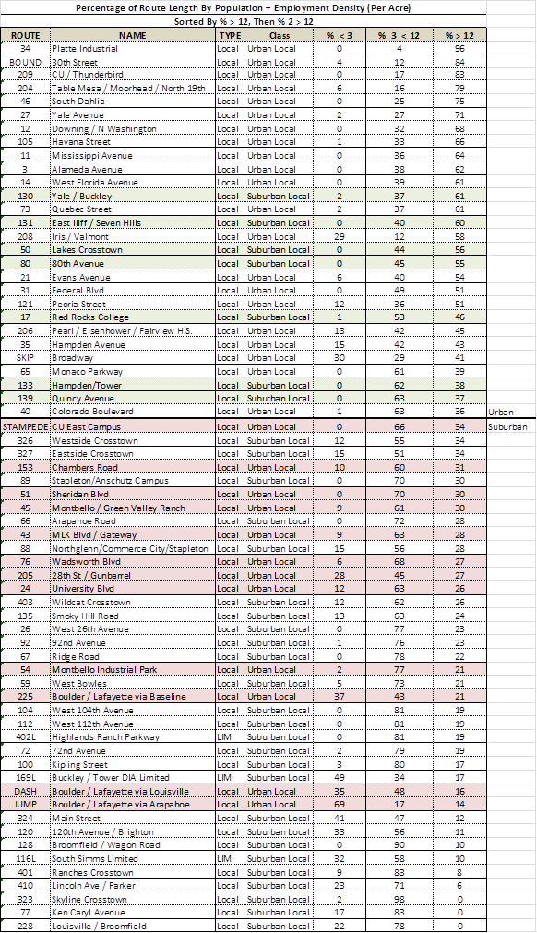

The following map illustrates the application of the density classification for Urban and Suburban routes.

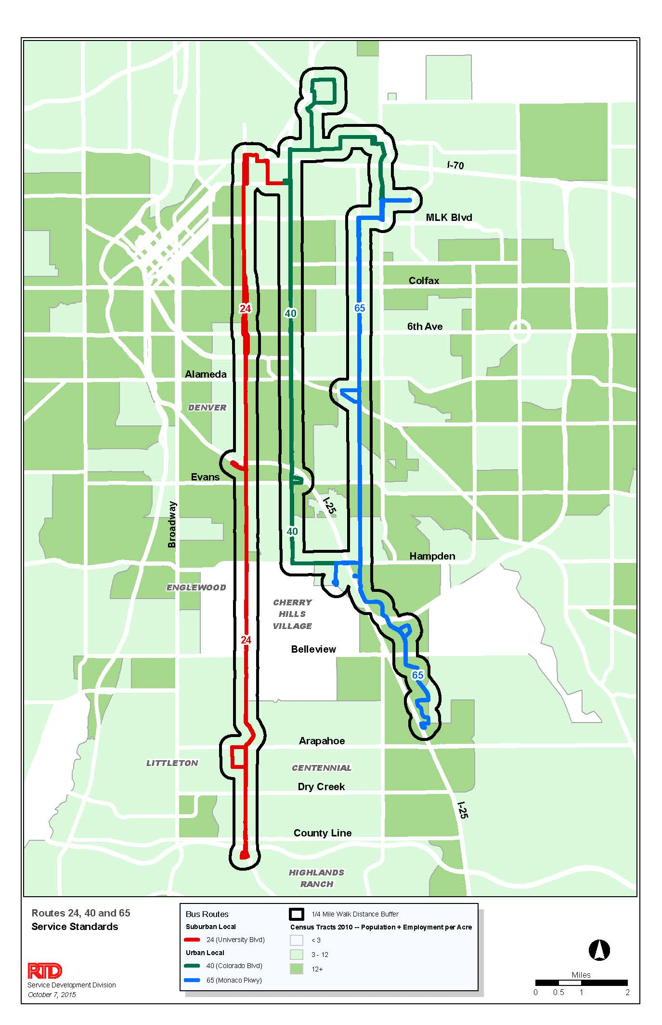

The following two charts depict the Urban and Suburban effectiveness-productivity performance charts with the revised classifications.

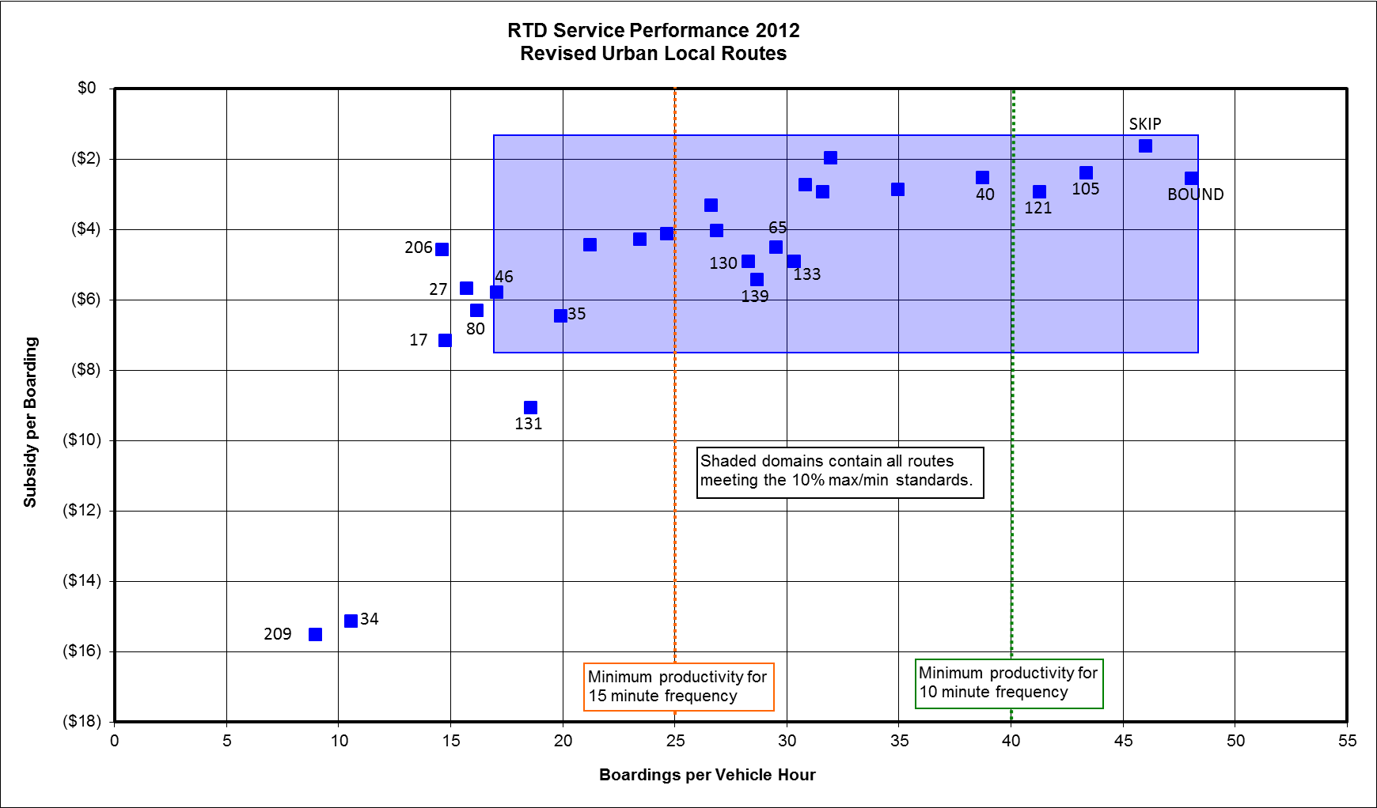

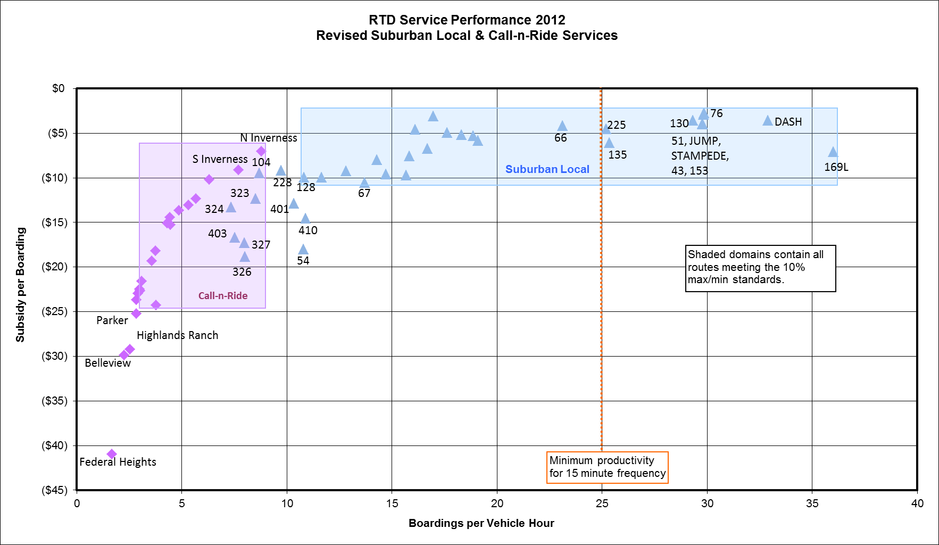

The following map depicts the revised Urban routes.

T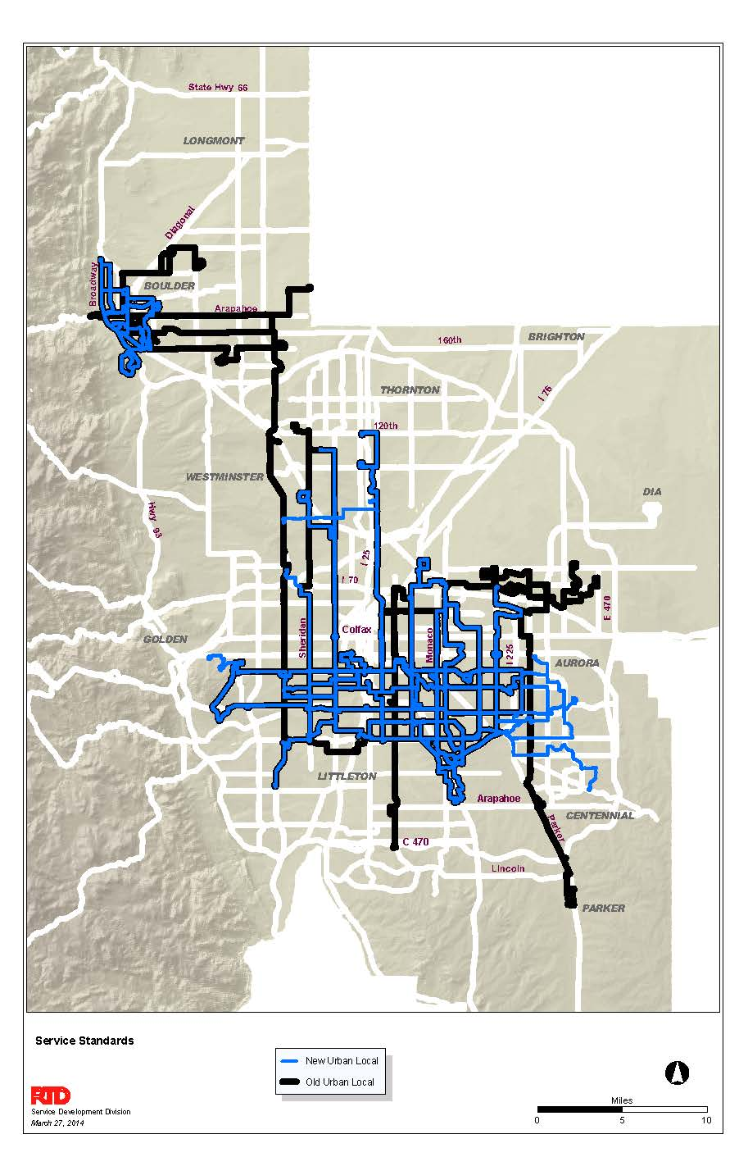

The following map depicts the revised Suburban routes.

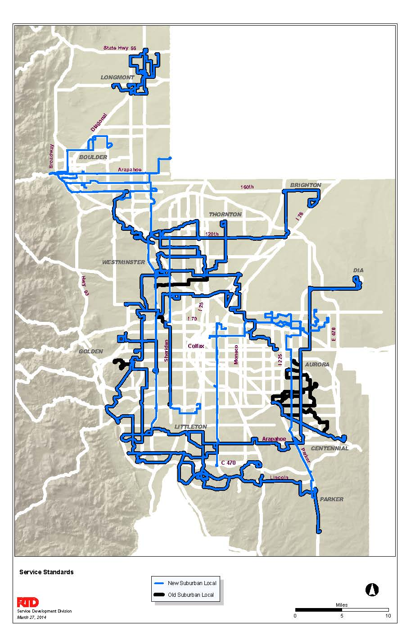

Regional Service Class

The following Express routes will be moved to the Local CBD class: 31X, 40X, 55X, 72X, 80X, 87X and 100X. The chart below shows the performance for the remaining Express routes (labeled) that will be included along with all the current Regional and SkyRide routes in this consolidated class. It should be noted that some Express and SkyRide routes will be discontinued and some Regional routes will be consolidated into the new Flatiron Flyer routes in 2016.

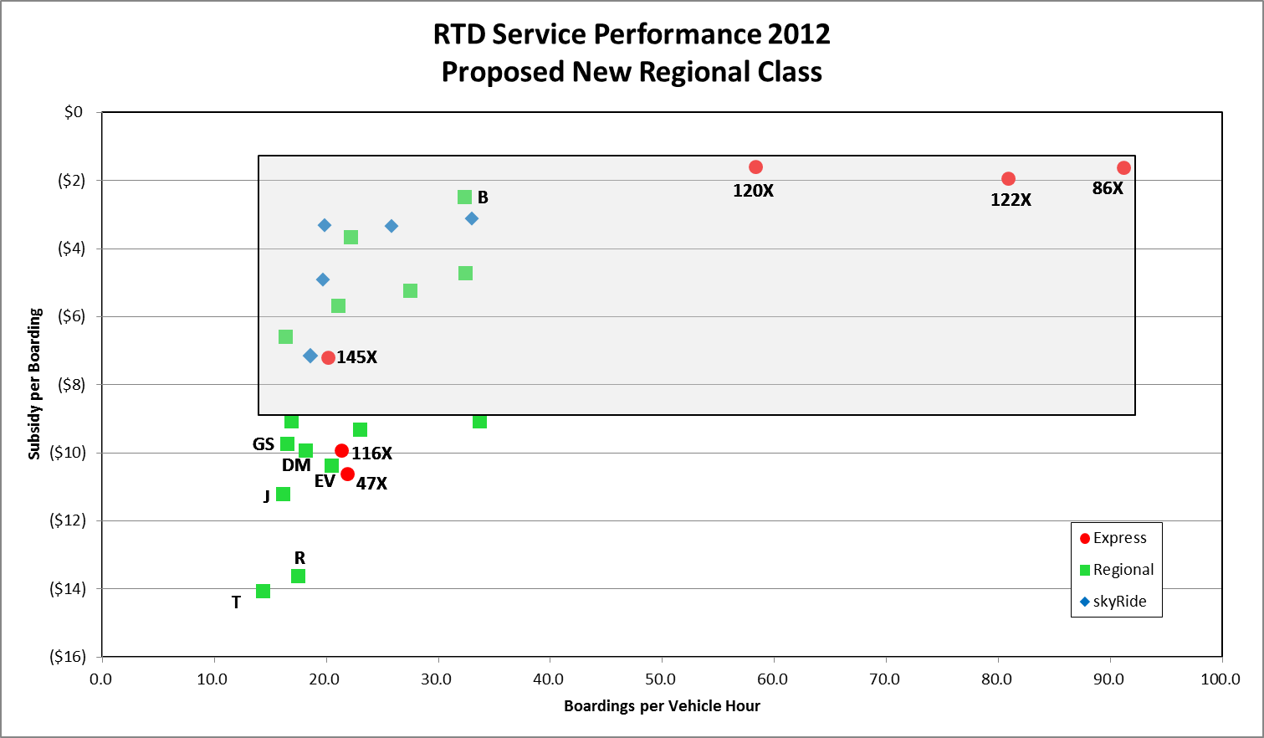

**Attachment B Service Coverage**

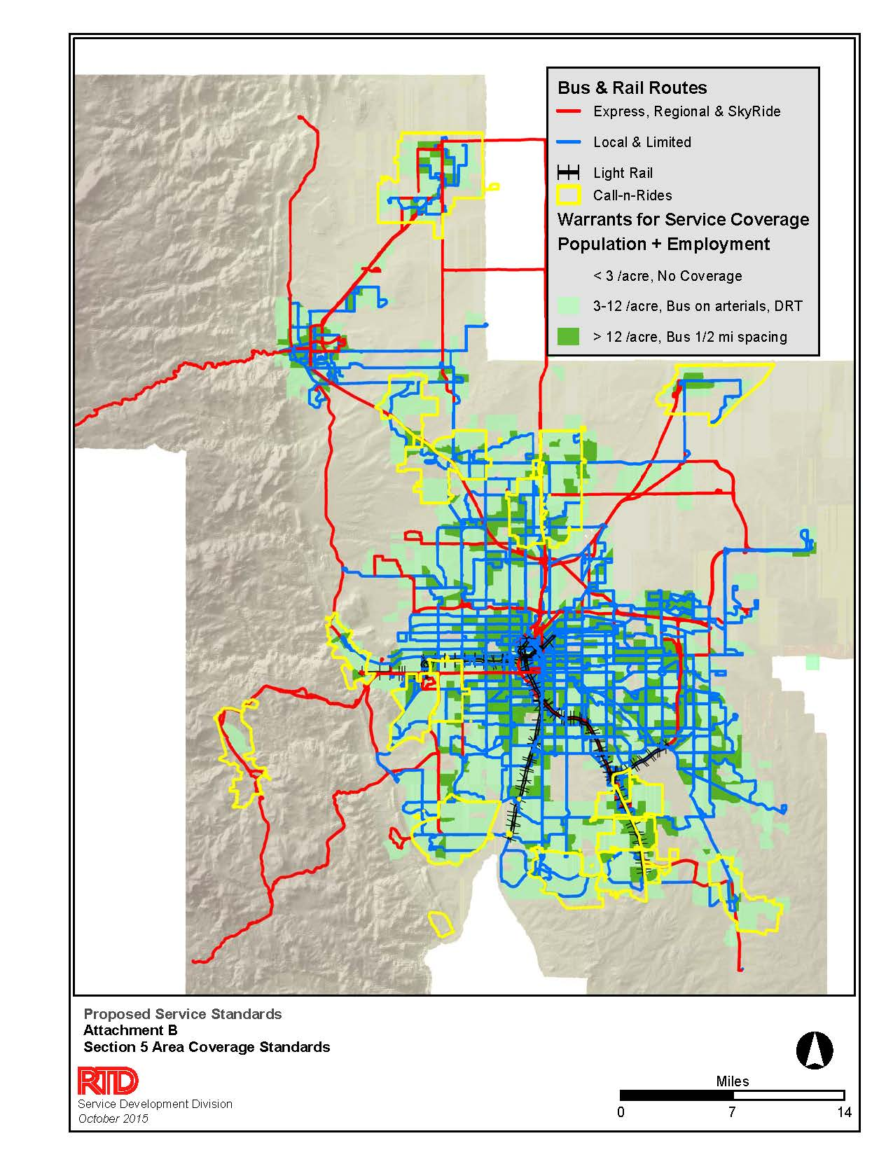

**Attachment C Regional Bus Service Performance**



**Attachment D Crowding Report Examples**

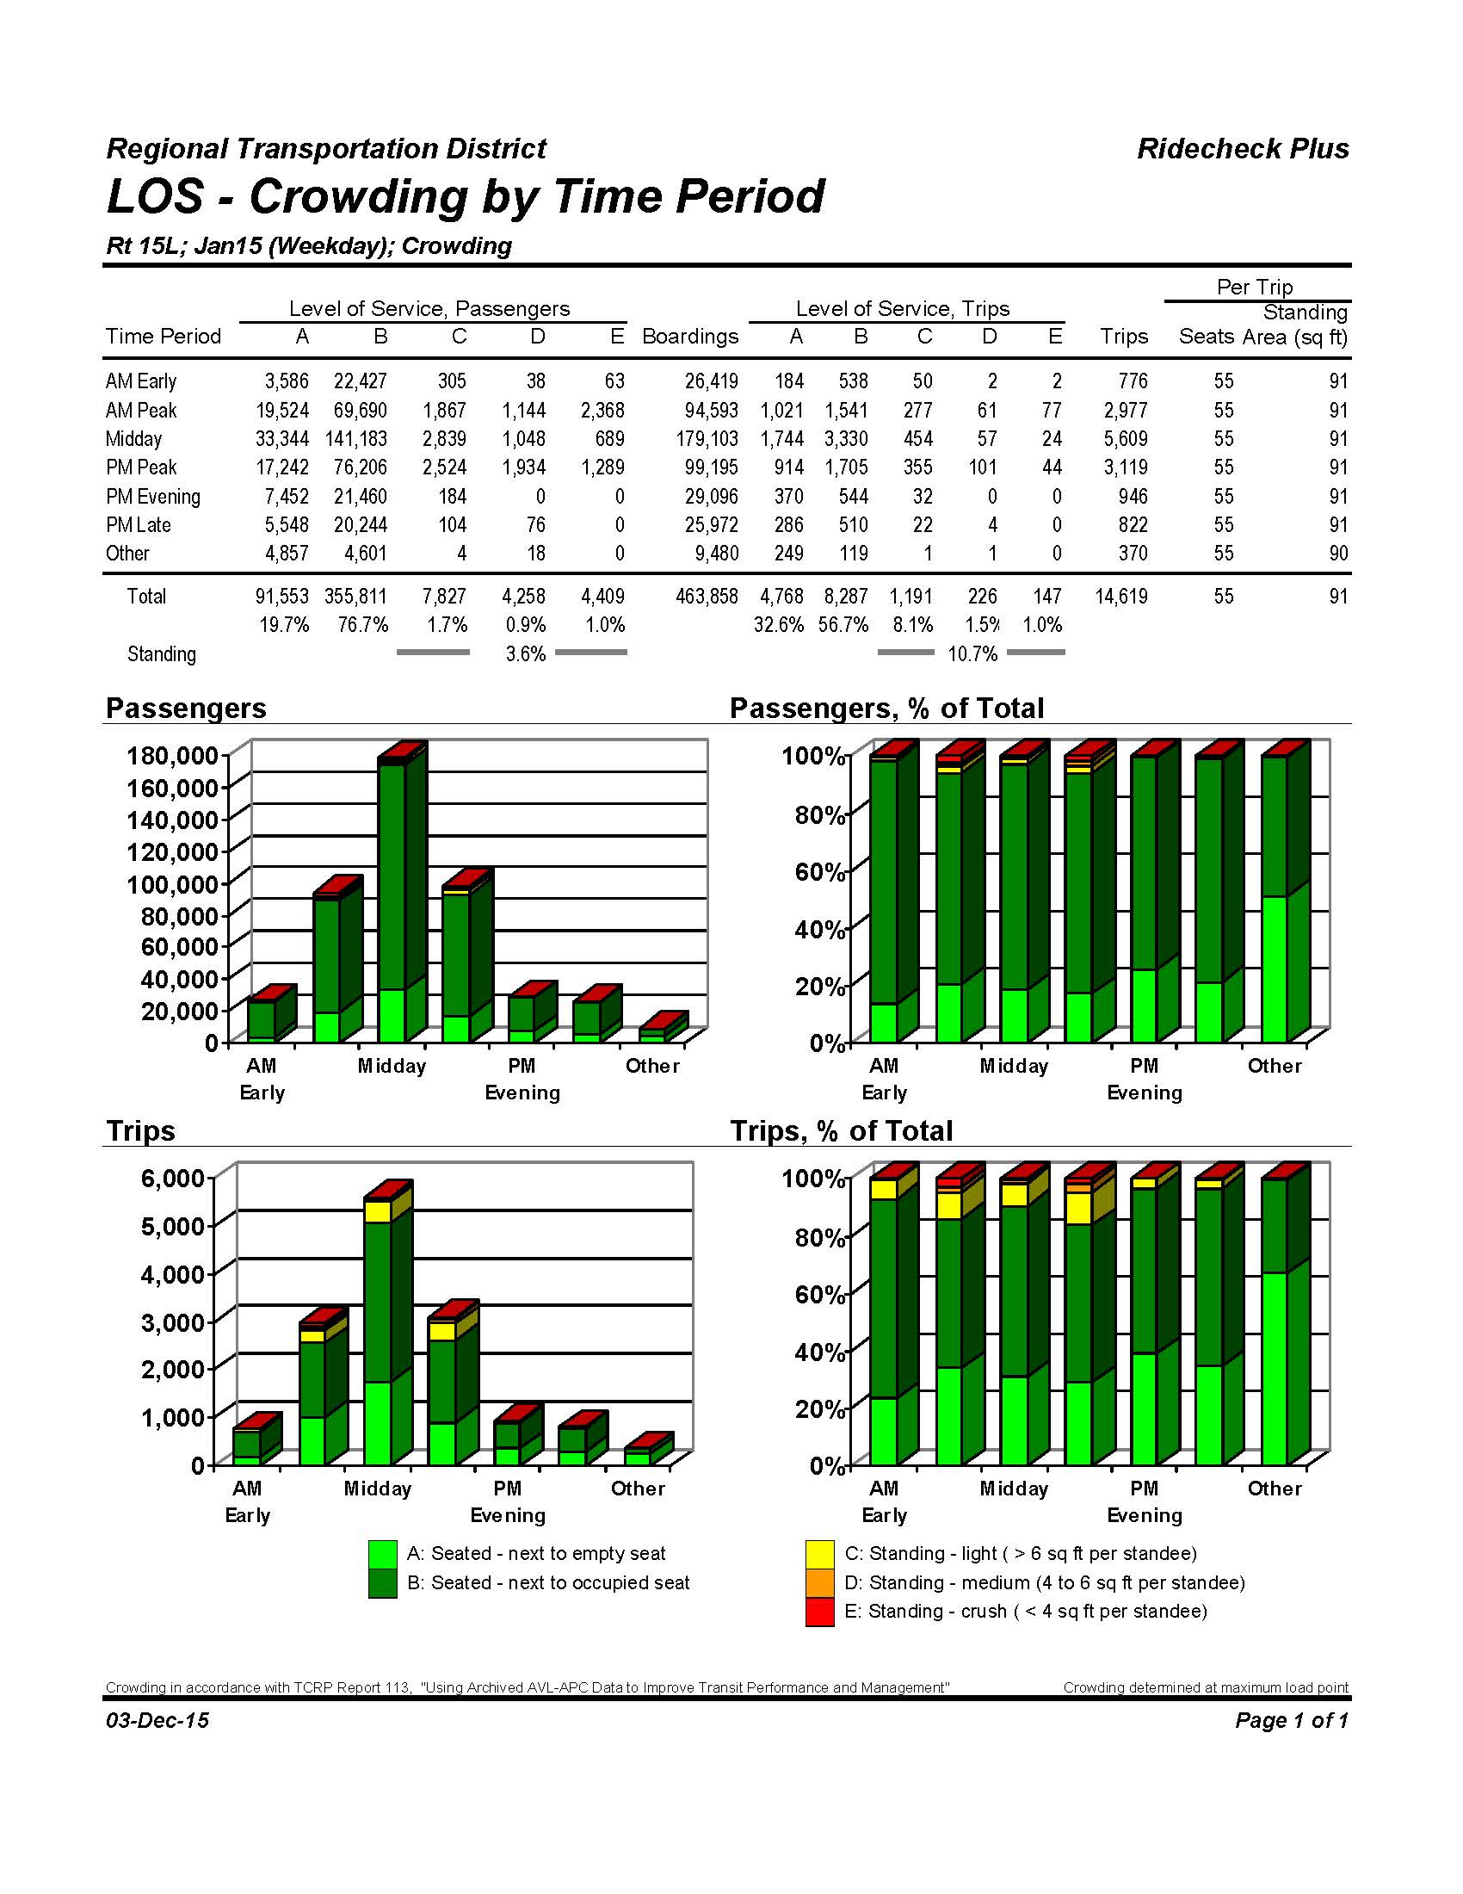

**Attachment D continued**

